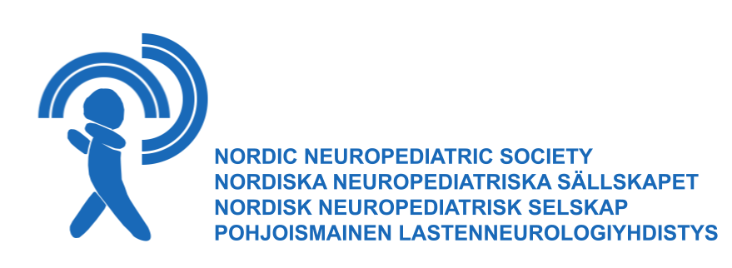

Nordic neuropediatric society trainee course

Neuromuscular diseases in children

Course leader: Professor Mar Tulinius. Lectures will be held by several invited speakers.

Program: The course will give an overview of neuromuscular diseases in children. The participant should after completion of the course be able to recognize different levels of motor unit affection from clinical findings, and also be able to explain different methods of workup in the diagnosis of children with neuromuscular disease. Further, from a known diagnosis be able to discuss specific aspects of multidisciplinary treatment, and have a knowledge of new treatment aspects for this group of patients.

The course will include an interactive part. A detailed program will be presented later.

Language: The course language will be English.

Date: 12-13 november 2015

Place: Ågrenska villan, Högåsplatsen 2, Göteborg (in central Göteborg)

Costs: 2000 DKK (includes participation fee, 2 lunches, coffee, 1 dinner)

Target group: The course will be directed to trainees in the field of neuropediatrics, from the Nordic countries. Maximum 25 participants.

Application: State your name, adress, invoice adress, mobile phone number, e-mailadress, place of work, number of years in the neuropediatric field.
Send application to Johan Aronsson, e-mailadress: johan.aronsson@rjl.se

Last date of application: August 31, 2015. First 6 applications from target group of each country will be accepted.

Contact:
mar.tulinius@gu.se
johan.aronsson@rjl.se

